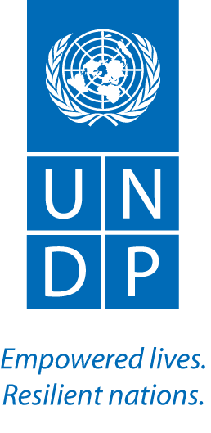

United Nations Development Programme
Project Document

Project Title:
Building A Resilient Community Health System to Prevent Infectious Diseases in Post-Ebola Sierra Leone

I.PROJECT SUMMARY
The Ebola Virus Disease (EVD) crisis had reversed efforts to provide universal coverage of quality health care across Sierra Leone. Whilst considerable investments have been and are continuing to be made towards strengthening the national health system, there remains a large gap in the access to health care, particularly for rural communities.
A survey conducted in March 2015 among 1,185 PHUs noted that majority of the periphery health units (PHUs) are lacking in infrastructure, (e.g. WATSAN facilities, electricity), adequate examination and treatment rooms, delivery wards etc., particularly in remote communities.
Since the end of the EVD outbreak, there have been high risks of concurrent health vulnerabilities, including outbreaks of vaccine preventable diseases such as measles in early 2015, a surge in malaria cases and deaths, acute malnutrition and maternal and neo natal mortality due to non-health facility. These outbreaks have underscored the urgent and unforeseen need to strengthen health outcomes at the community level.

The focus on the restoration of basic health services presents a unique opportunity to complement the health system strengthening efforts at the central level with the involvement of local communities in improving community health and WASH infrastructures, health seeking behaviour amongst vulnerable populations and restoring trust and utilization of health services through the support of field level advocacy amongst community health workers.

The project focuses on restoring basic access to health care with a focus on maternal, child and adolescent health for vulnerable rural communities. This is aligned to the commitment of the Government of Japan to promoting universal health coverage as well as addressing urgent gender and youth issues. In addition, the project seeks to kick-start the economic recovery process, with modest cash for work initiatives to immediately improve community health infrastructures

2. PROJECT CONTENTS

2.1 Overview
This proposal is designed to provide support to vulnerable communities with specific emphasis on maternal, child and adolescent cohorts in the restoration of access to basic health care and the promotion of resilient communities in rural Sierra Leone. The project aims to strengthen universal health care coverage and health delivery systems in twelve communities of two border districts by; supporting local governance structures pertaining to communal health service delivery, promoting appropriate health seeking behaviour as in line with MOHS guidelines, community health care workers policy, aiding the delivery of quality health care through the rehabilitation of WASH features and the provision of a supporting framework for increased community led advocacy targeting vulnerable communities health seeking behaviour.

As of present, two projects funded by the Government of Japanese are operationalized by UNDP in the two border districts of Kambia and Kailahun respectively. The “Increasing access to basic health care and community led development in rural communities”, is currently being implemented in 100 communities across the aforementioned districts and focuses on strengthening community governance and basic service delivery support mechanism for village development with health and WASH rehabilitation as a suitable entry point.
The Sierra Leone section of the Manu River Regional project, entitled; “supporting and strengthening sub regional post- Ebola medical surveillance and socio-economic recovery initiatives in West Africa” focuses on the community surveillance, strengthening community health infrastructure, community response mechanism and local development planning in additional 30 bordering communities. The overall objective is to reinforce overall strengthening of rural health care and population resilience.
This pilot project, will fortify rather than duplicate the above two interventions by concentrating on maternal health facilities and maternal health care promotion. The most vulnerable communities, in terms of access rates to maternal health care and quality of maternal health care services (facilities, distance to PHU) will be targeted by UNDP in a gender conscious manner. Selection of the communities will be determined by the level of need as identified by the District Health Medical Team (DHMT) , in tandem with the wiliness of communities to participate and agree to the principles of engagement to ensure equitable access, transparency and inclusivity. Maternal and Child Health Posts (MCHPs) within each the selected communities will be targeted in this pilot project for further support and sensitisation campaigns.
The project is based on UNDP’s Ebola Recovery Strategy approach to support the post-Ebola national recovery plans “the President’s Recovery Priorities”. The planned interventions are linked to the UNDP Strategic Plan 2014-2017, the regional programme for Africa; UNDP’s partnership with AU and its agencies; and by UNDP’s agreements with other regional organisations and development partners involved in the Ebola recovery efforts.
2.2 General Objective
The project aims at promoting an integrated and gender sensitive approach to improving health outcomes for vulnerable border communities by restoring access to basic health care and changing health seeking behaviour.
2.2.1 Specific Objectives
1.Support and strengthen the capacities of existing community governance structures to take an active role in the determination and prioritisation of community health needs, including the development of health infrastructure plans with specific attention placed on maternal, child and adolescent access to health care. By strengthening the capacity of local authorities in planning, implementation and monitoring of health infrastructure works and service delivery, real ownership and meaningful community engagement will be fostered. By using this bottom-up approach to strengthening and developing the capacity of community structures ( i.e. village development committees, maternal and child health posts ), this will ensure that district development plans reflect the views and needs of the selected communities. In total, twelve communities will be selected in the two districts.
2. Support to the rehabilitation and refurbishment of local health and grassroots infrastructures for improvement of access to basic health services in twelve communities. These may include but are not limited to the upgrading of the water supply, installation of solar panels to help maintain the cold chain for vaccines and essential medicines, repairs to the health facility etc.
3. Support local community health promotion activities to improve health-seeking behaviour. Heath promotion and outreach activities will be strengthened in all twelve communities through the medium of the media campaigns and outreach.
2.3 Outcomes, outputs and priority activities
The project is designed for one (1) year and entails the following key outputs:
Outcome 1: To strengthen universal health care coverage and health delivery systems in Sierra Leone.
Output 1: Capacities of communities for health governance are strengthened
The project will seek to strengthen capacity and integrate existing community governance structures such as paramount chiefs, village development committees (VDCs), village health committees (VHC) women’s associations, youth associations, CBO’s and local NGO’s etc. in the twelve selected communities to take a more active role in the determination and prioritisation of community health needs with a particular focus on maternal, child and adolescent access to health care within the PHU framework.
Utilising the previously supported community structures and taking into consideration the findings of a joint district assessment concerning capacity mapping and constraints related to health access barriers, community engagement in the planning and implementation of health interventions surrounding gender focused mechanism for increasing female usage and access to medical care on the local level, will be encouraged.
The project will facilitate and support each of the health/development committees in the twelve selected communities to identify and assess both general and maternal focused health issues and plan and implement their health priorities for greater community resilience. The Local Councils and the District Medical Teams will actively engage with communities in planning to address these issues and include prioritized ones in the district development plans.
Output 2: Community health infrastructure and health seeking behaviours improved to support universal care coverage
According to a rapid assessment carried out by UNDP in January, 2017, the absence of even basic maternal facilities poses a constant threat to women accessing prenatal and postnatal care in Kailahun and Kambia district respectively. Dilapidated maternal wards lacking adequate modern equipment or reliable energy sources were a common theme amongst the majority of communities assessed. The project therefore aims to directly support the implementation of at least one intervention in each of the twelve (12) selected border communities to improve health infrastructures in accordance to the health development plans developed and under the guidance from the DHMT. The infrastructure rehabilitation interventions will be identified through an assessment and mapping and prioritized by the beneficiary community in line with Village Development Plan. It is envisaged that through these health infrastructure improvements, at least twenty four thousand (24,000) people in border communities will have access to improved health facilities.
To reinforce the community interventions, UNDP will embark on a health promotion campaign that targets both maternal, child and adolescent audiences as well as conveying the importance of communal responsibility to health emergencies and encouraged health seeking behaviours. Through facilitated discussions with such health workers (MCHP, TBA, VDC,VHC) and community representatives, culturally and linguistically relevant health promotion materials can be developed and /or modified with specific attention to maternal, child and adolescent health care. The modified or recirculated health promotion materials will reflect self-determined and prioritised community needs in relation to maternal needs in each of the twelve selected communities, thereby improving the knowledge and understanding of what is expected of health providers by the public and additionally the routine services available to mothers and their children.
Community dramas and media will be utilised, via the health sensitisation activities, to propagate knowledge and interest amongst the public, as these mediums have shown to be effective when transmitting key public health messages. The inclusion of media in terms of broad casting information relating to maternal health services and importance of such services , as determined by the community health/development committees and DHMT will be rolled out as a means of further promoting behavioural change .Through increasing community outreach activities, it is envisaged that the health outcomes for twenty four thousand (24,000) people in the twelve communities will be improved, in addition to increasing demand for services at the local health facility.
3. Summary BUDGET and LINKAGE TO SDG’S
Outcome:
Outputs | Activities | Projected budget (in USD) | Linkage to SDG’s
Output 1  Capacities of communities for health governance are strengthened | - Support the capacity of relevant community institutions (i.e. VDCs) to plan and implement their health priorities | 85,000 | SDG 3.d  Strengthen the capacity of all countries, in particular developing countries, for early warning, risk reduction and management of national and global health risks
Output 2  Community health infrastructure and health seeking behaviours improved to support universal care coverage | - Refurbishment and improvement to community health/WASH infrastructures  - Support community health outreach and health promotion targeting women and youth | $360,111 | SDG 9. Build resilient infrastructure, promote inclusive and sustainable industrialization foster innovation  SDG 3.8 Achieve universal health coverage, including financial risk protection, access to quality essential health-care services and access to safe, effective, quality and affordable essential medicines and vaccines for all
SUB - TOTAL |  | $445,111
- Communications (1%)  - Independent Audit (4%)  - Monitoring and evaluation (2%)  - Project Management  - HR Costs  - Operational costs/Transport | Promoting visibility of project and the Government of Japan  Measuring results and financial management  Monitoring delivery and results | 241,000
UNDP GMS (8%) |  | 54,889
Sub-total |  | 295,889
TOTAL |  | $741,000

4. MEASURABLE TARGETS
Intended Programme Component as stated in the UNDP Sierra Leone Recovery Strategy and Programme Results and Resource Framework:
Programme Component 3: Livelihood and Enterprise Recovery Support
Programme Component 4: Health System Strengthening
Output indicators:
Output 3.1: Social Protection and Safety-net for the most vulnerable enhanced
Output 3.2: Sustainable Livelihoods and Economic Recovery of prioritized Groups Supported
Output 4.1: Governance of Health Systems strengthened
Output 4.4: Delivery of basic and essential health services reinstated
Output 4.5: Community trust in the health sector restored
Project Intended Outcomes:
Outcome 1: To strengthen Universal Health Care coverage and health delivery systems in Sierra Leone
Project Title and ID (ATLAS Award ID): TBD
EXPECTED OUTPUTS | ANNUAL OUTPUT TARGETS | INDICATIVE ACTIVITIES | RESPONSIBLE PARTIES | AMOUNTS in (USD)

Output 1 :Capacities of communities for health governance are strengthened
Indicator 1: Number of assessments/maps of existing community structures  Baselines: 100 PHU structures assessed in 2016  Indicator 2: Number of health/development committees capacity strengthened  Baseline: 100 VDC’s mobilised in 2016 for community led development | Targets: 12 PHU’S and their maternal health units assessed  Targets: 12(one per health facility supported) | Activity 1: Support an assessment/mapping of the capacity needs of existing community structures  Activity 2: Strengthen the capacity of the existing community health/development committees in partnership with Local Councils and their respective district health medical teams (DHMTs) and Community Health Workers | UNDP Country Office  Community Health/development committees  Community Health Facility | 35,000 USD
Indicator 4: Number of health infrastructure development plans developed by local authorities through participatory processes  Baseline: 100 health plans developed in 2016 by 100 VDC’s | Targets: 12 (one per health facility supported) | Activity 4: Development of prioritized health infrastructure development plans through participatory processes that complement district development plans specifically concerning maternal, child and adolescent access to health care. | UNDP Country Office  Existing local governance structures  Community Health/development committees  Local Councils  DHMT | 20,000 USD
Indicator 5: Number of community based monitoring teams  Baseline: 0 | Target: 12 (one monitoring team per health facility supported) | Activity 5: Strengthen capacity of local institutions to manage the implementation of infrastructure works  Activity 6: Establish and strengthen community based monitoring teams to monitor upgrades of health infrastructures | UNDP Country Office  Existing local governance structures  Community Health/development committees | 30,000 USD

Output 2: Community health infrastructure and health seeking behaviours improved to support universal care coverage
Indicator 6: Number of infrastructure rehabilitation interventions implemented in target border communities to improve health infrastructures in accordance to the plans developed  Baseline: 100 communities in 6 chiefdoms have implemented improvement of WASH features in 2016. This will be built upon for further investment in maternal , child and adolescent health features within the target communities  Indicator 7: Number of people that have improved access to health services  Baseline: 0 | Targets: 12 (at least one project per community/health facility)  Targets: 24,000 (2,000 people per community) | Activity 7: Refurbishment / expansion /upgrade of health infrastructure including solar panel instalment, in accordance to health infrastructure plans developed with specific emphasis on maternal, child and adolescent health needs  Activity 8: Strengthen capacity of women through livelihood and financial literacy training and establishment of women health saving schemes and linking the groups with the micro finance institutions.  Activity 9: Livelihood recovery support to the most vulnerable youth including young women through cash for work for the rehabilitation of the community health infrastructure. | UNDP Country Office  Community Health/development committees  Local Councils | 330,000 USD
Indicator 8: Number of culturally and linguistically relevant health promotion material developed and/or modified with specific attention given to maternal, child and adolescent health priorities  Baseline: 100 communities in 2016 previously undergoing the development of tailored community sensitisation material.  Indicator 9: Number of people that have access to health promotion materials  Baseline: 100 communities in 2016 that have access to modified or newly disseminated health promotion materials | Targets: 12 (at least one health promotion material per health facility)  Targets: 24,000 (2,000 people per community) |  | UNDP Country Office  Community Health/development committees  DHMT  Community Health Facility
 |  | Activity 8: Support review of existing and available health promotion materials  Activity 9: Support development and/or modification and dissemination of health promotion and IEC materials based on community health priorities |  | 20,000 USD
Indicator 10: Number of outreach activities conducted by local health workforce ( MCHP)  Baseline: # of PHUs in 2016 previously mobilized for the sensitization of residing communities  Indicator 11: Number of people accessed through health outreach activities | Targets: 12(at least two additional outreach activity per health facility)  Targets: 24000 (2,000 people per community) | Activity 10: Support and expand outreach efforts by community health workforce to targeted communities, reflecting prioritised community health needs with emphasis on maternal, child and adolescent health needs. | UNDP Country Office  Community Health Facility  Community Health/development committees  DHMT | 10,111 USD

Project management, coordination, M&E, communication
Indicator 12: Project implementation, monitoring, evaluation, reporting, coordination and operation | Target: 3 | Staff: project manager, admin finance, project monitoring and support officer  Communication and visibility,  Office recurrent cost  Travel  Vehicle maintenance and fuel  Monitoring and Evaluation  Direct Project Cost (DPC) 4% | UNDP Country Office | 241,000 USD
Subtotal |  |  |  | 686,111 USD
GMS (8%) |  |  |  | 54,889USD
TOTAL |  |  |  | 741,000 USD

5. MANAGEMENT ARRANGEMENT
The project will be implemented under the Direct Implementation Modality of UNDP. Main government counter parts to this project are Ministry of Local Government and Rural Development and Ministry of Health and Sanitation at the national level. The project implementation will be closely coordinated with the Local councils and DHMT of the respective districts. The Village Development Committees and Village Health Committees are the main target counter parts of the project.
As per the UNDP project management guideline a project board consisting of UNDP, MLGRD, MOHS, WHO, UNICEF will oversee and provide strategic direction for the effective implementation and achieving the result. The project manager will present the progress and challenges to the Project Board once in three months and seek guidance for the implementation of the next quarter activities.
INVOLVEMENT OF JAPANESE STAFF
UNDP will build upon the foundations of the initial Japan funded community heath governance projects currently being implemented to ensure quick impact, sustainability and consistency to the highest level. The project will be managed by a multi-national team including Japanese staff who specialise in health economics and community development. The Japanese staff will be part of routine monitoring of project sites to maintain the highest level of delivery for the country office.
6. GENDER SENSITIVE ELEMENT
This proposal is in support of universal health coverage for all Sierra Leoneans, particularly women, children and adolescents. The support of health services and utilisation of health services will aid in the improvements of health outcomes for women and youth in Sierra Leone.
7. VISIBILITY FOR JAPAN
UNDP will facilitate visibility for the Government of Japan through its website, social media and other communication outputs. Upon launching and delivery of each key output, press releases will be issued and communication materials produced. Signpost will be placed at project sites with mentioning of the support received from the Government of Japan and UNDP. Branding strategies and logo use will be decided in consultation with the Government of Japan.
9. PROJECT MAP(S)
Image 1: District Level, Sierra Leone
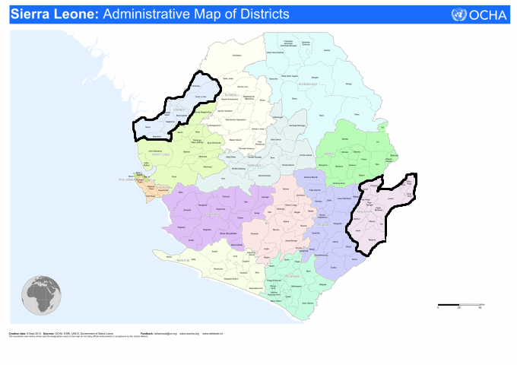
Source: OCHA, Sierra Leone (2016)

Image 2: Kambia Target Chiefdoms, Sierra Leone
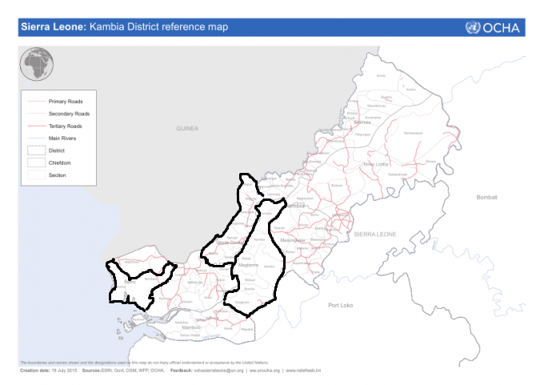
Source: OCHA, Sierra Leone (2016)

Image 3: Kailahun Target Chiefdoms, Sierra Leone
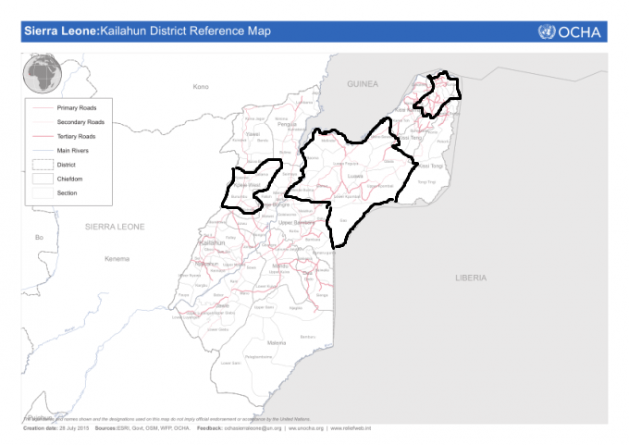
Source: OCHA, Sierra Leone (2016)
10. CONTACT DETAILS
UNDP Country Office
12 Wilkinson Road,
Freetown,
Sierra Leone.

Team Leader of Inclusive Growth and Sustainable Development:
Mr Ghulam Sherani (Ghulam.sherani@undp.org)

